Building inspection · 18 October 2026

Project details

Project
Building | Lindenhof apartments · Example
Address | Musterstraße 12, 12345 Musterstadt
Example | Fictional project · 18 October 2026

Participants
Site manager | Lena Weber · Lindenbau · Beispiel  lena.weber@lindenbau.example · +49 000 10001
Planner | Mara König · Planwerk · Beispiel  mara.koenig@planwerk.example · +49 000 10002
Contractor | Jonas Berger · Fassadenwerk · Beispiel  jonas.berger@fassadenwerk.example · +49 000 10003

Documentation details

Inspection
Date | 18 Oct 2026
Documentation number | LH-2026-001
Purpose | Record visible building-envelope defects and define further investigation and follow-up.
Property | Lindenhof apartments - Musterstraße 12, 12345 Musterstadt
Inspection time | 09:15-11:15
Inspection method | External visual inspection from accessible ground-level areas
Prepared by | Mara König - building surveyor
Follow-up reviewed | 19 October 2026

Inspection participants
Planner | Mara König · Planwerk · Beispiel  mara.koenig@planwerk.example · +49 000 10002
Site manager | Lena Weber · Lindenbau · Beispiel  lena.weber@lindenbau.example · +49 000 10001

Task overview
Task | Location | Responsible | Status | Deadline | Page
Task 1 · Arrange assessment of the damaged balcony edge | Pin 1.1.1 · Defect | Lena Weber · Lindenbau · Beispiel | In progress | 23 Oct 2026
Task 2 · Measure moisture and inspect the downpipe connection | Moisture | Mara König · Planwerk · Beispiel | Open · Overdue | 18 Oct 2026

Pin 1
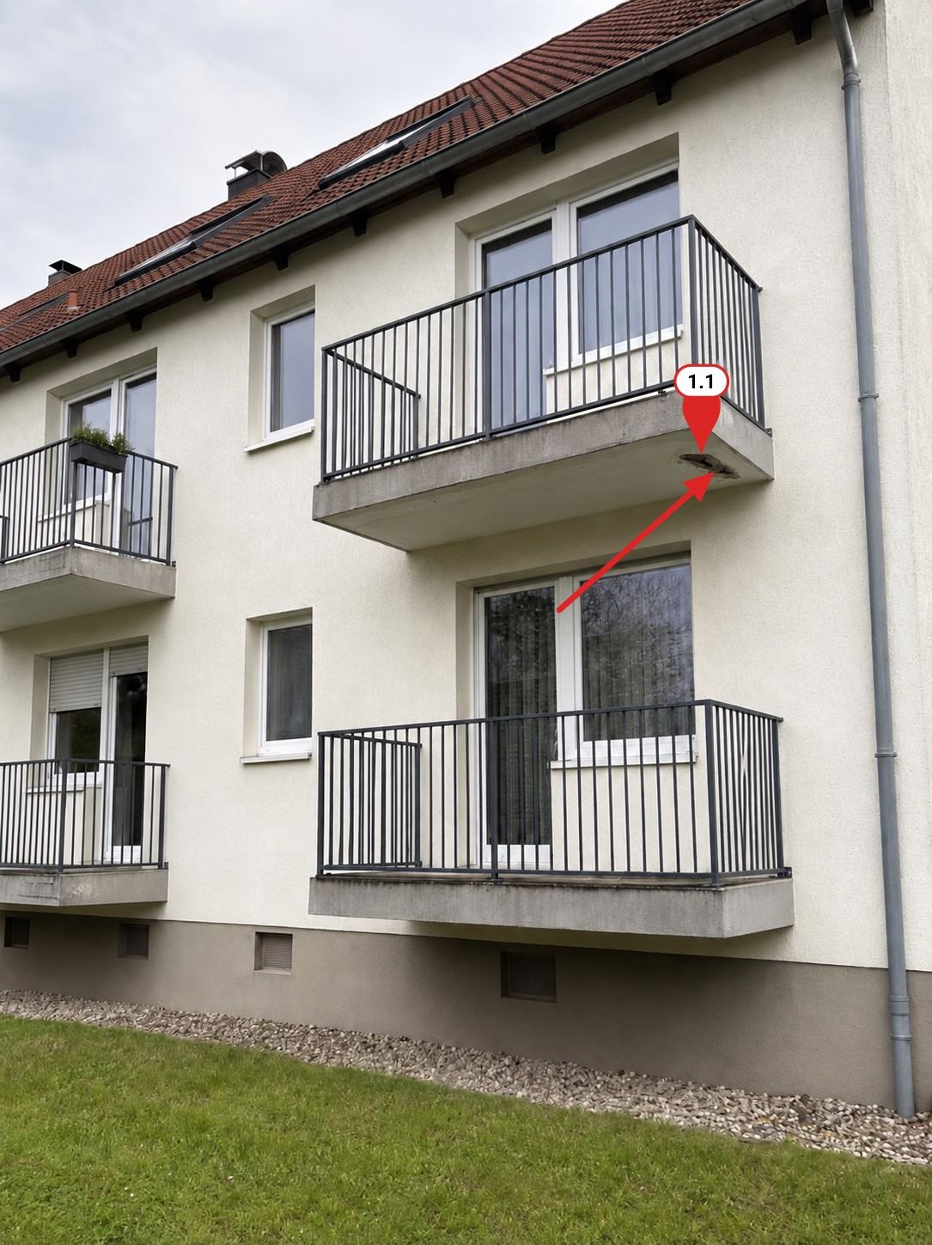
Figure 1 ● Concrete damage

Pin 1.1
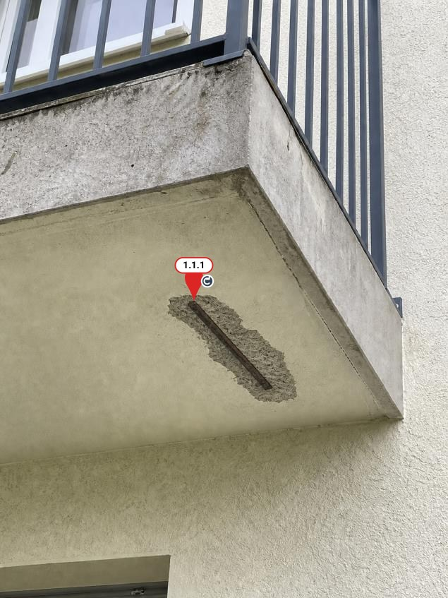
Figure 2

Pin 1.1.1 · Defect
Component | Concrete spalling · Balcony underside

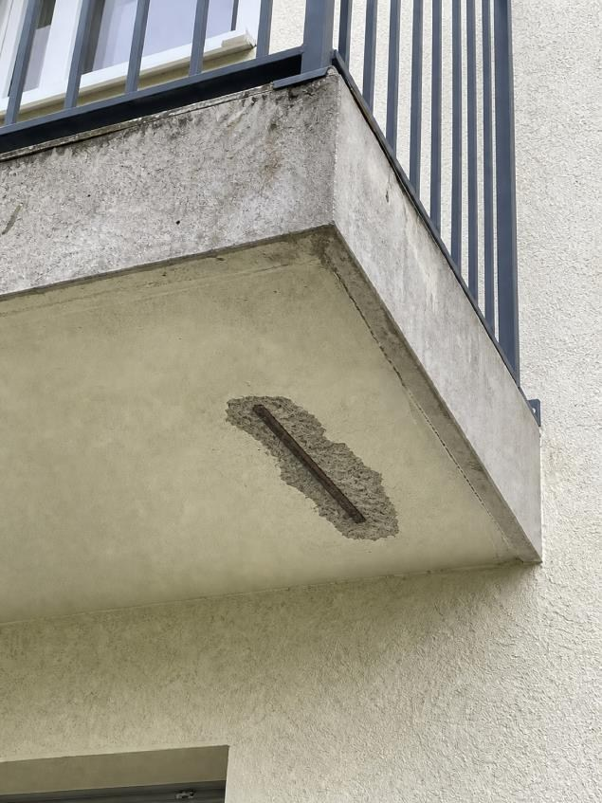  Figure 3 · Concrete spalling · Balcony underside | Assessment and investigation - exposed reinforcement  The visible condition is consistent with deterioration of the concrete cover associated with reinforcement corrosion. The initiating cause and the extent of corrosion cannot be established by visual inspection. Further loose or detached concrete may be present beyond the visible opening.  A competent concrete specialist should inspect the underside and adjacent slab edges at close range, establish the extent of unsound concrete and assess cover and reinforcement condition. The slab top, waterproofing, edge details and drainage should also be checked for possible moisture entry. The specialist should determine any further testing and whether structural assessment is required.  Maintain the precautionary restriction below the affected area until it has been assessed. Define repair measures from the investigation findings; this visual record does not establish that the balcony is safe for unrestricted use.

Tasks and measures
Task 1 · Arrange assessment of the damaged balcony edge
Responsible | Lena Weber · Lindenbau · Beispiel
Status | In progress
Deadline | 23 Oct 2026 (Europe/Berlin)
Comments | Access is secured. Coordinate the inspection with the specialist before defining the repair.
Evidence | Figure 3

Moisture
Component | Moisture at the plinth

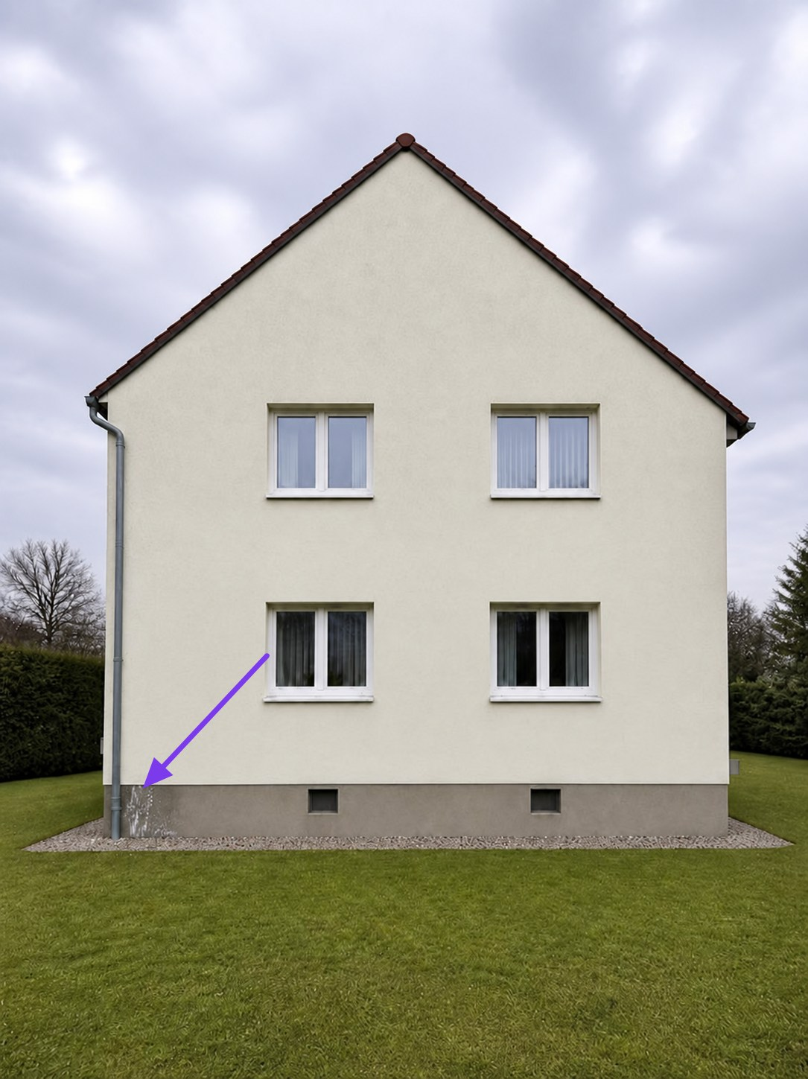  Figure 4 · West elevation - downpipe and plinth  ● Moisture-related findings | Location and context - west plinth  The marked area is at the foot of the rainwater downpipe on the west elevation, close to the north-west corner. The overview records the relationship between the staining, downpipe, gravel strip and adjacent ground. The linked detail photograph records the surface condition.

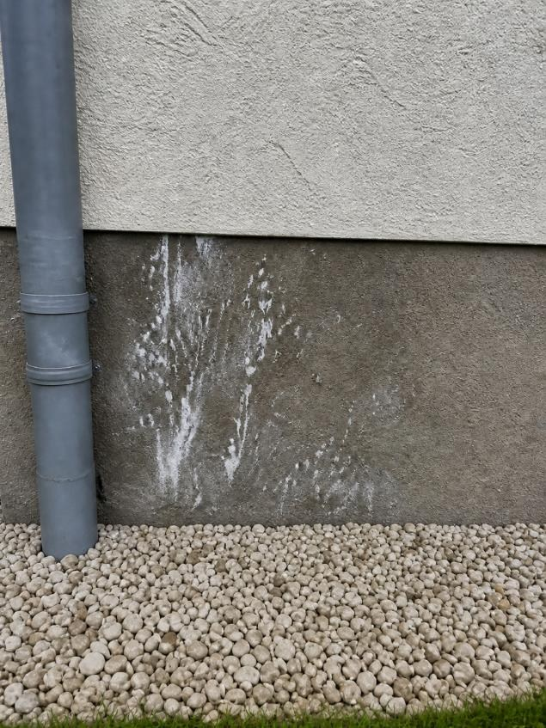  Figure 5 · Moisture at the plinth | Finding - staining and deposits at the plinth  At the west elevation, beside the rainwater downpipe near the north-west corner, irregular dark staining is visible in the rendered plinth. The affected area is approximately 0.60 m wide and extends to about 0.45 m above the adjoining ground level, estimated visually.  Patchy whitish deposits and local changes to the surface coating are visible. The boundary with the less affected render above is irregular. These features are compatible with repeated wetting and drying, but the deposits have not been identified by testing.  No material moisture measurements or inspection of the concealed wall layers was undertaken. Inspect the downpipe joints and drainage connection, adjacent ground levels and plinth detailing, then record comparative moisture readings before deciding on remedial work.

Tasks and measures
Task 2 · Measure moisture and inspect the downpipe connection
Responsible | Mara König · Planwerk · Beispiel
Status | Open · Overdue
Deadline | 18 Oct 2026 (Europe/Berlin)
Comments | Please add readings and a photo of the connection to this finding.
Evidence | Figure 5

