Building inspection · 18 October 2026

Project details

Project
Building | Lindenhof apartments · Example
Address | Musterstraße 12, 12345 Musterstadt
Example | Fictional project · 18 October 2026

Participants
Site manager | Lena Weber · Lindenbau · Beispiel  lena.weber@lindenbau.example · +49 000 10001
Planner | Mara König · Planwerk · Beispiel  mara.koenig@planwerk.example · +49 000 10002
Contractor | Jonas Berger · Fassadenwerk · Beispiel  jonas.berger@fassadenwerk.example · +49 000 10003

Documentation details

Inspection
Date | 18 Oct 2026
Documentation number | LH-2026-001
Purpose | Record visible building-envelope defects and define further investigation and follow-up.
Property | Lindenhof apartments - Musterstraße 12, 12345 Musterstadt
Inspection time | 09:15-11:15
Inspection method | External visual inspection from accessible ground-level areas
Prepared by | Mara König - building surveyor
Follow-up reviewed | 19 October 2026

Inspection participants
Planner | Mara König · Planwerk · Beispiel  mara.koenig@planwerk.example · +49 000 10002
Site manager | Lena Weber · Lindenbau · Beispiel  lena.weber@lindenbau.example · +49 000 10001

Contents
Task overview
Inspection scope and method
Pin 1 · Defect
Pin 1.1 · Defect
Pin 1.1.1 · Defect
Moisture
Inspection
Safety observation
Precautionary access restriction
Photo location
Technical assessment
Recommended further action
Summary and follow-up

Task overview
Task | Location | Responsible | Status | Deadline | Page
Task 1 · Arrange assessment of the damaged balcony edge | Pin 1.1.1 · Defect | Lena Weber · Lindenbau · Beispiel | In progress | 23 Oct 2026
Task 2 · Measure moisture and inspect the downpipe connection | Moisture | Mara König · Planwerk · Beispiel | Open · Overdue | 18 Oct 2026
Task 3 · Review the documented crack at the window opening | Inspection | Jonas Berger · Fassadenwerk · Beispiel | Ready for review | 20 Oct 2026
Task 4 · Secure the access area below the balcony | Safety observation | Lena Weber · Lindenbau · Beispiel | Closed | 18 Oct 2026

Inspection scope and method
The inspection concerns externally visible defects to the reinforced-concrete balconies, rendered plinth and window surrounds at Lindenhof apartments, Musterstraße 12, 12345 Musterstadt. Its purpose is to record the condition, identify the need for further investigation and coordinate follow-up work.
The elevations were inspected from accessible ground-level areas on 18 October 2026, between 09:15 and 11:15. The overview plan is schematic and is used for orientation only. Findings are located on the plan and linked to overview and detail photographs. Dimensions quoted in the findings are approximate visual estimates.
No opening-up, hammer sounding, reinforcement measurements, material moisture or salt testing, or measured crack monitoring formed part of this inspection. Concealed construction, the extent of any hidden deterioration and structural adequacy cannot be determined from this visual record alone.
Sample documentation: project details, people, dimensions and follow-up records are synthetic. Photographs are adapted from the earlier public example.

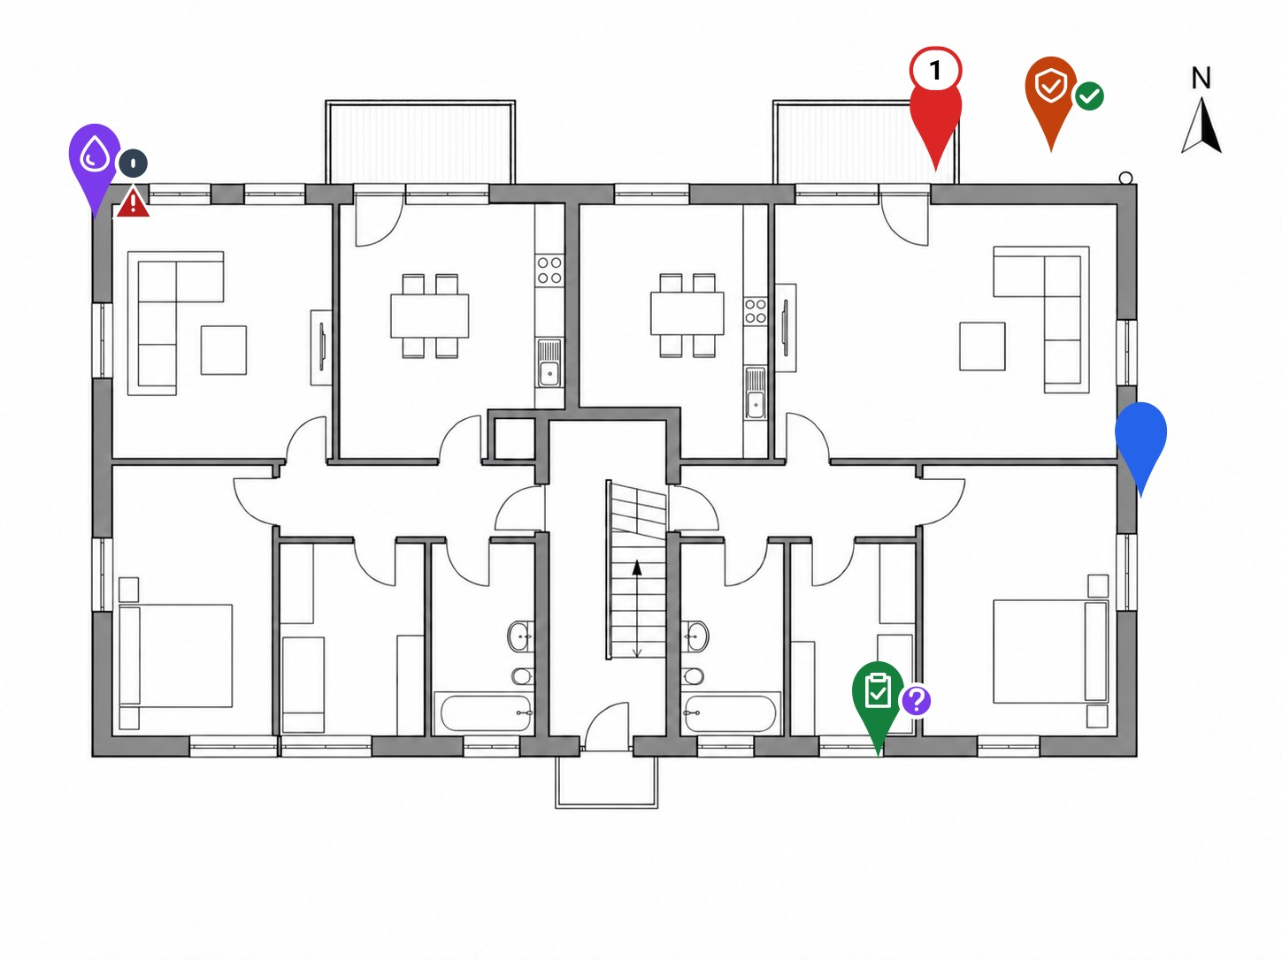
Figure 1 · Overview plan · schematic, not to scale
● Concrete damage ● Moisture-related findings ● Crack inspection ● Precautionary access restriction ● Overview photo location

Pin 1 · Defect
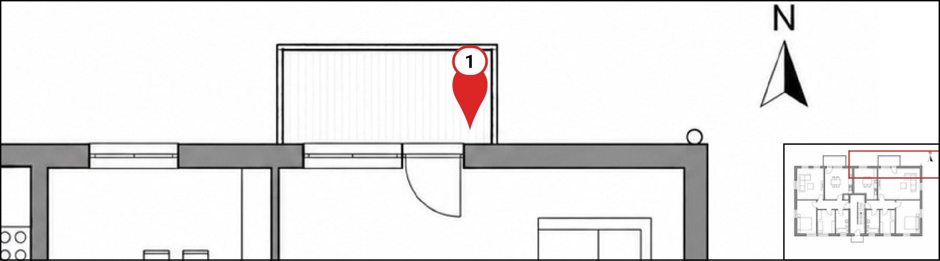
Component | Balcony · North elevation

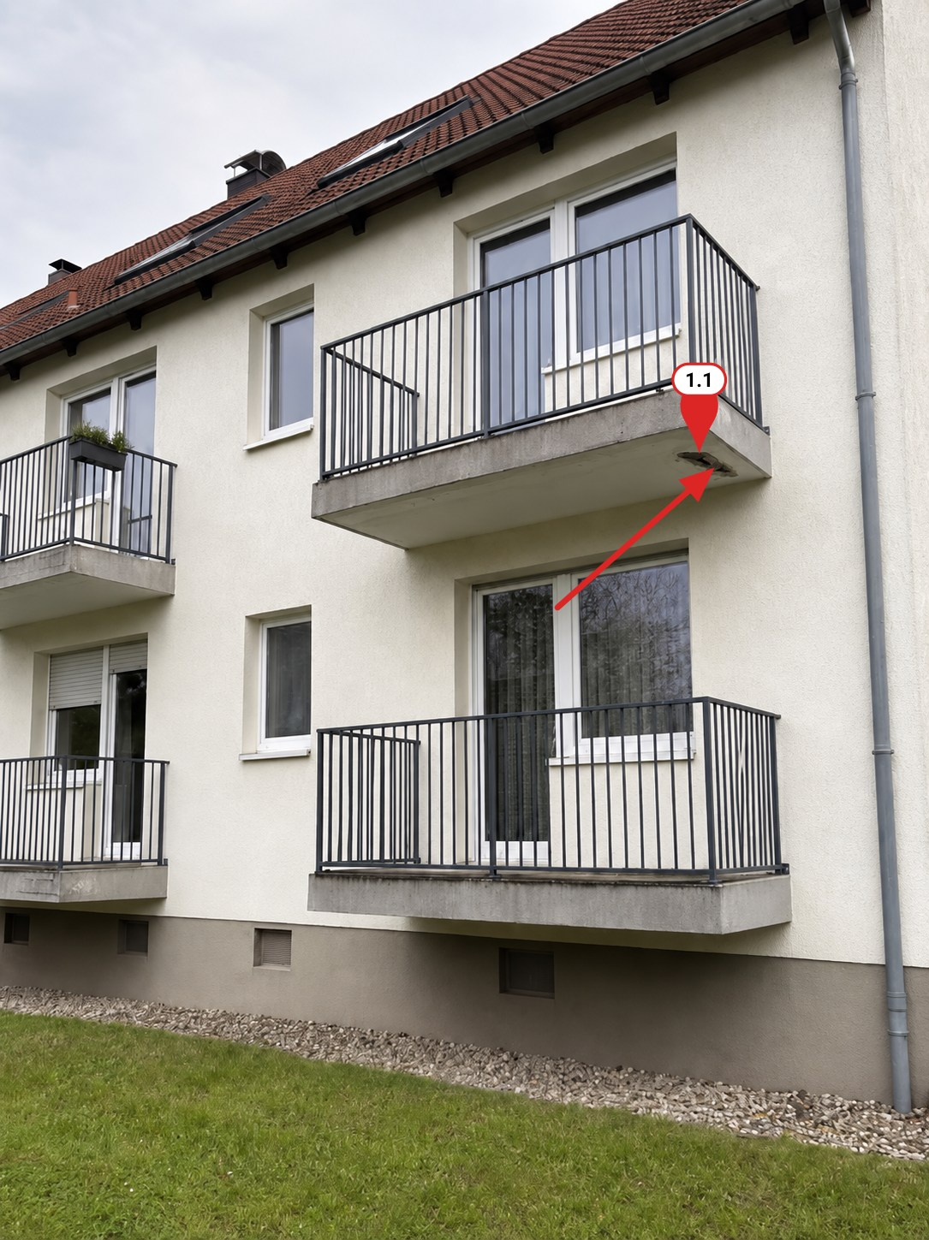  Figure 2 · North elevation - eastern first-floor balcony  ● Concrete damage | Location and overview  The affected element is the eastern first-floor reinforced-concrete balcony on the north elevation. The overview photograph records its position above the ground-floor balcony and adjoining garden access. Local loss of concrete is visible on the underside towards the outer eastern edge.  The marked location links to the closer photograph and the detailed finding. The accessible area below the defect requires precautionary control pending a close inspection of the concrete.

Pin 1.1 · Defect
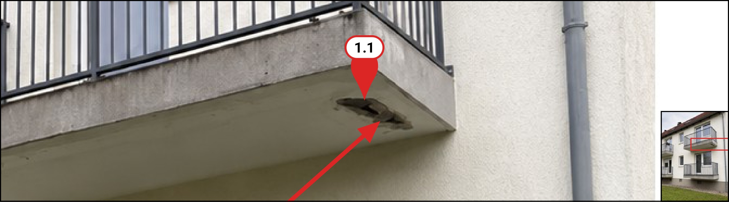
Component | Balcony · North elevation

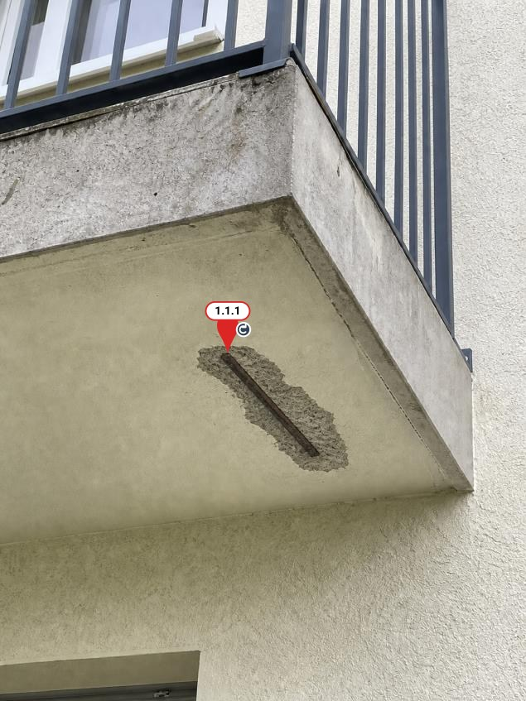  Figure 3 · Balcony · North elevation | Finding - balcony underside  An irregular area of concrete spalling is visible on the underside of the eastern first-floor balcony slab on the north elevation. The affected area is approximately 40 × 20 cm, estimated visually.  Within the spalled area, a reinforcing bar is exposed over an estimated length of approximately 18 cm. Brown discoloration is visible on the steel and adjacent concrete. Small fractures and local losses are apparent around the margins of the exposed area.  The condition was recorded visually from ground level. No hammer sounding or opening-up of adjacent concrete was undertaken. The depth of deterioration, remaining reinforcement cross-section and extent of any concealed delamination have not been established.

Pin 1.1.1 · Defect
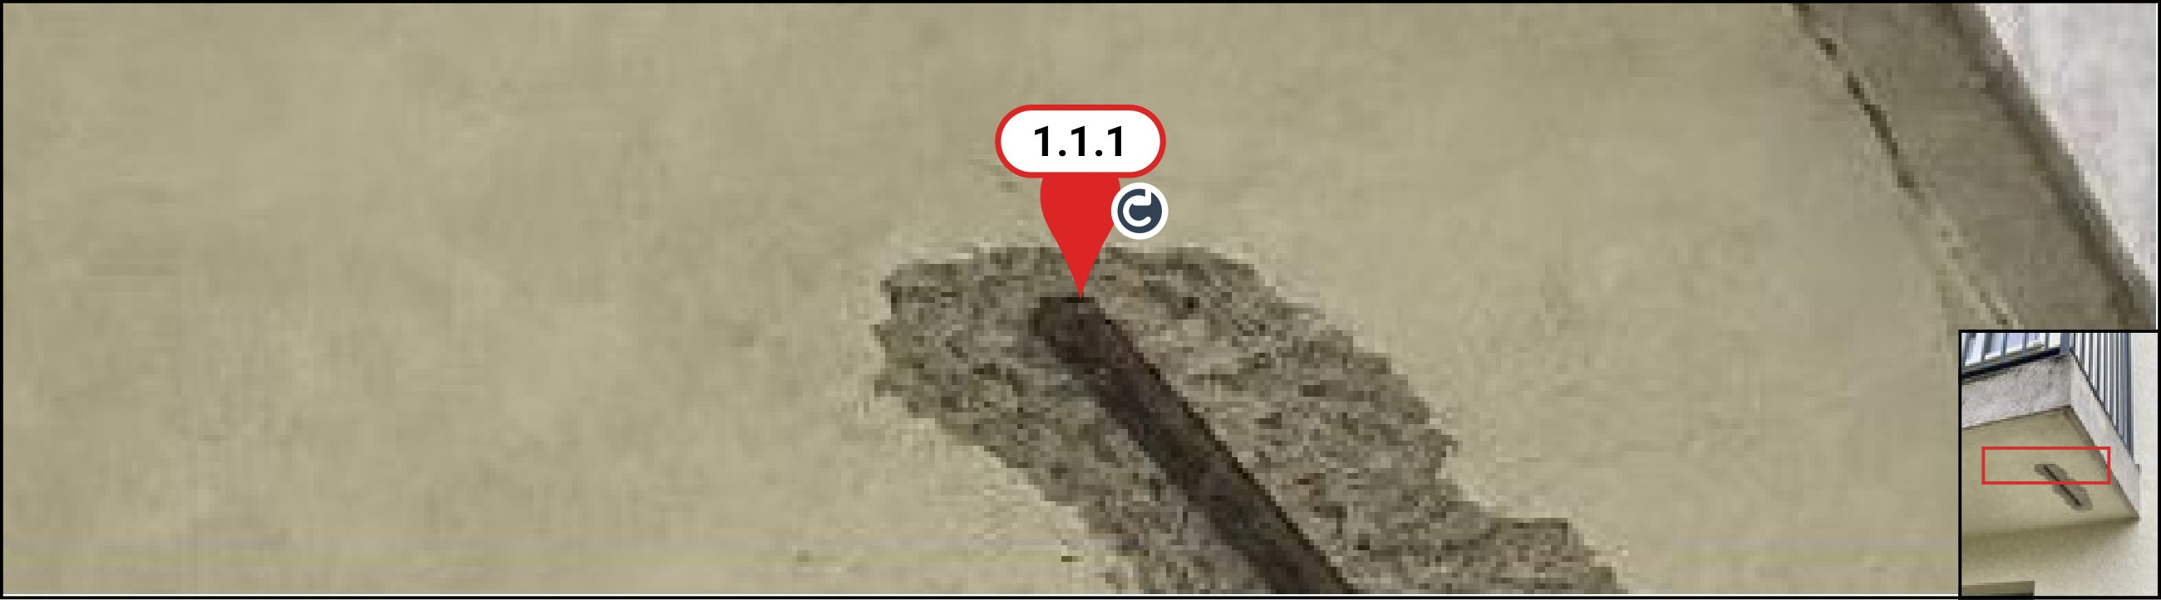
Component | Concrete spalling · Balcony underside

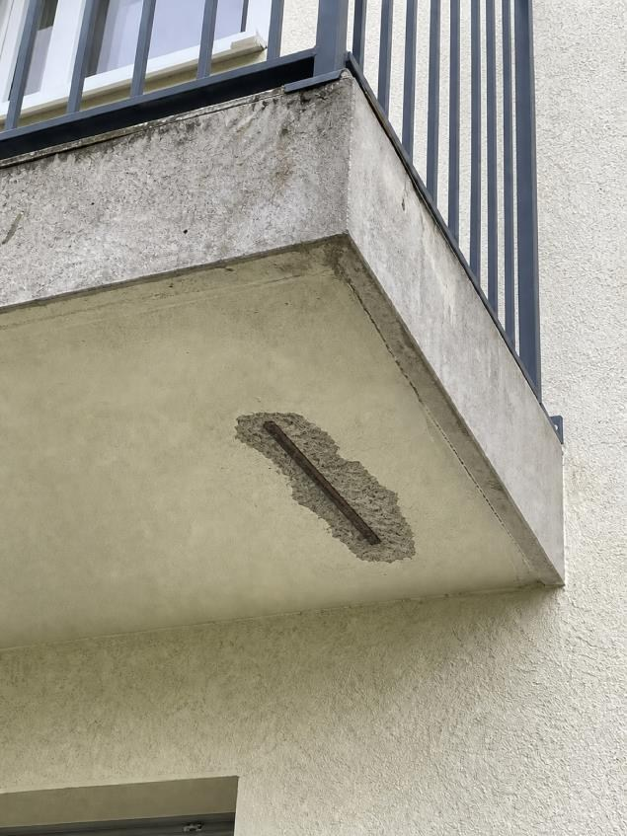  Figure 4 · Concrete spalling · Balcony underside | Assessment and investigation - exposed reinforcement  The visible condition is consistent with deterioration of the concrete cover associated with reinforcement corrosion. The initiating cause and the extent of corrosion cannot be established by visual inspection. Further loose or detached concrete may be present beyond the visible opening.  A competent concrete specialist should inspect the underside and adjacent slab edges at close range, establish the extent of unsound concrete and assess cover and reinforcement condition. The slab top, waterproofing, edge details and drainage should also be checked for possible moisture entry. The specialist should determine any further testing and whether structural assessment is required.  Maintain the precautionary restriction below the affected area until it has been assessed. Define repair measures from the investigation findings; this visual record does not establish that the balcony is safe for unrestricted use.

Tasks and measures
Task 1 · Arrange assessment of the damaged balcony edge
Responsible | Lena Weber · Lindenbau · Beispiel
Status | In progress
Deadline | 23 Oct 2026 (Europe/Berlin)
Comments | Access is secured. Coordinate the inspection with the specialist before defining the repair.
Evidence | Figure 4

Moisture
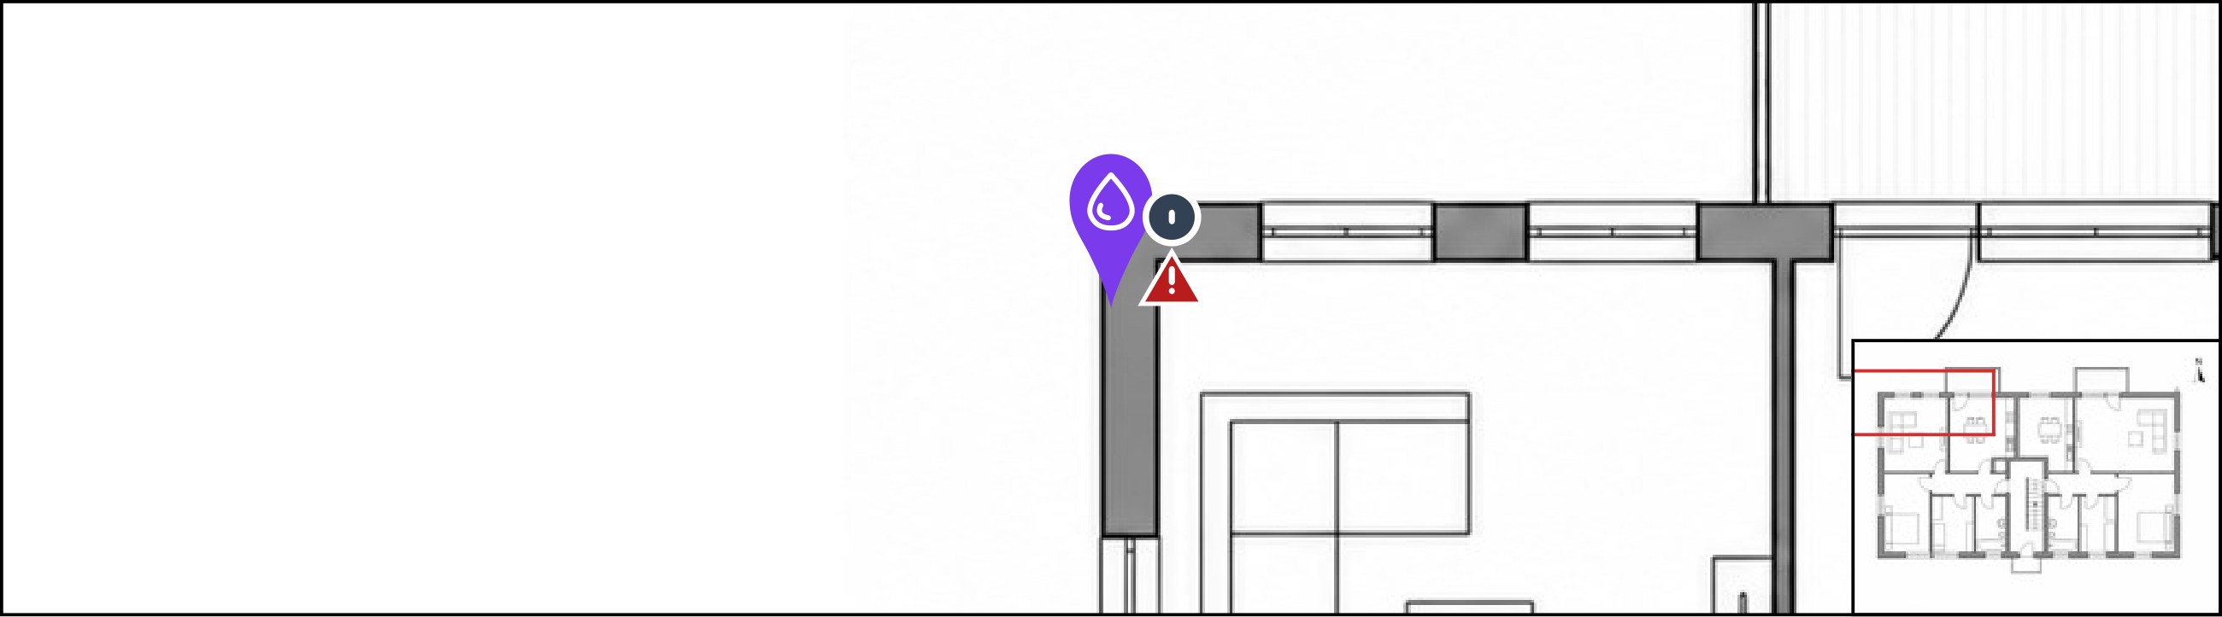
Component | Moisture at the plinth

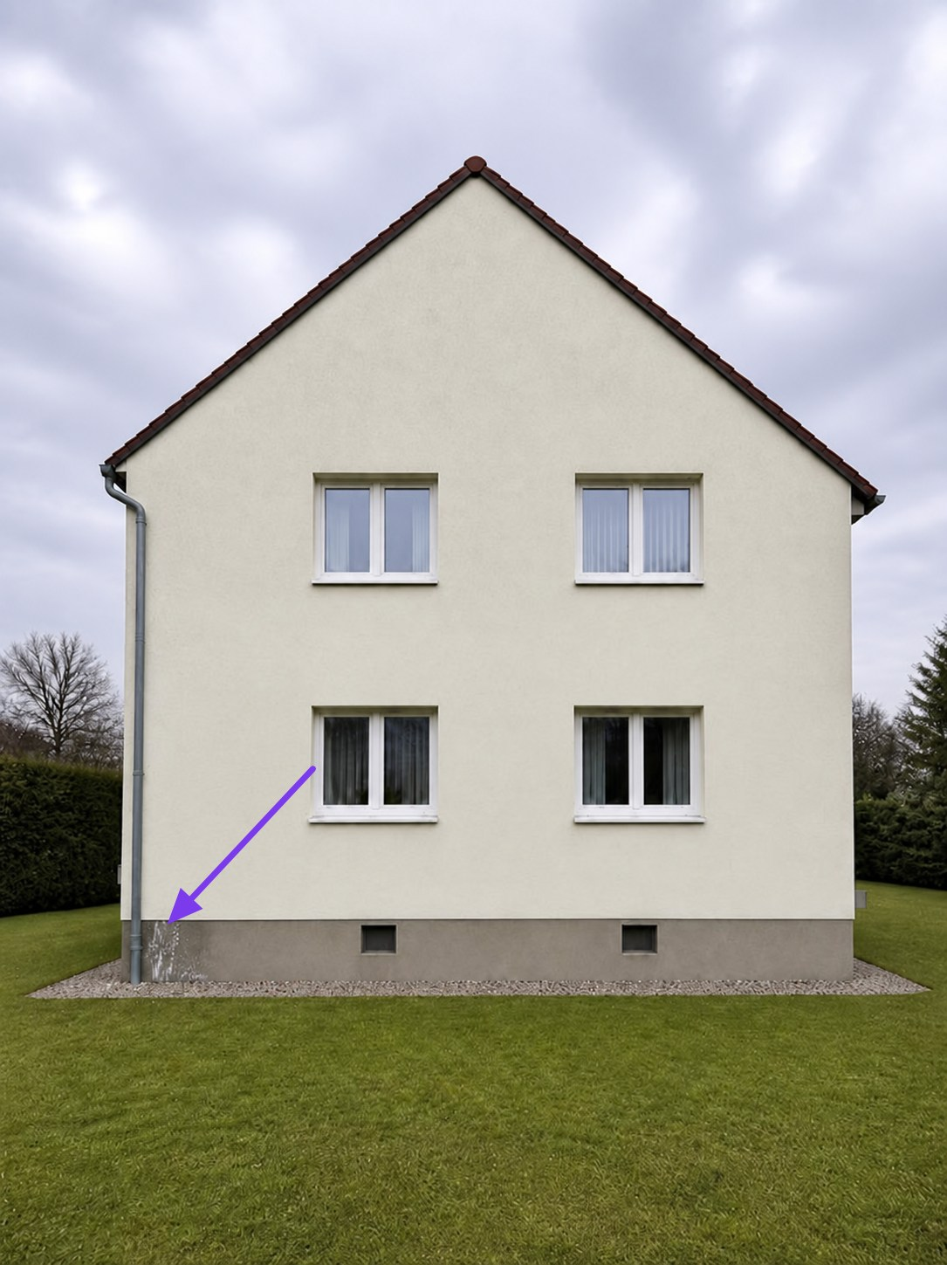  Figure 5 · West elevation - downpipe and plinth  ● Moisture-related findings | Location and context - west plinth  The marked area is at the foot of the rainwater downpipe on the west elevation, close to the north-west corner. The overview records the relationship between the staining, downpipe, gravel strip and adjacent ground. The linked detail photograph records the surface condition.

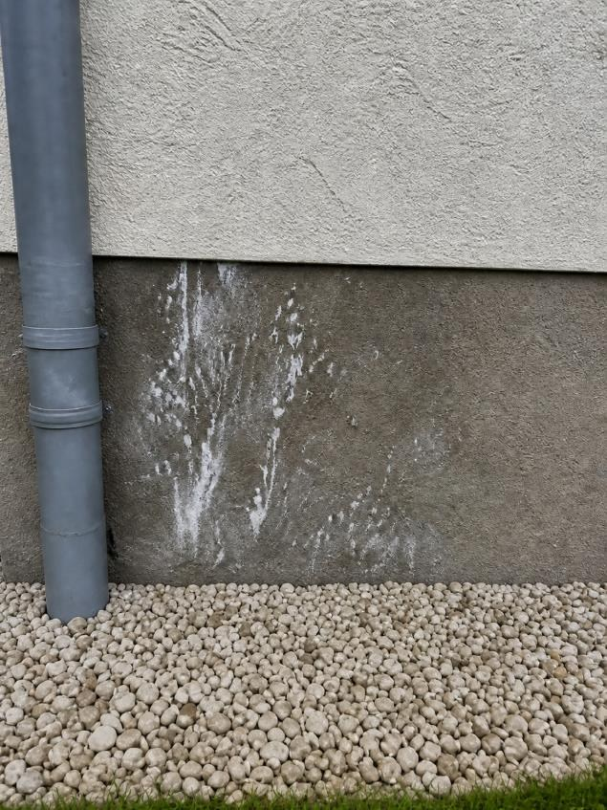  Figure 6 · Moisture at the plinth | Finding - staining and deposits at the plinth  At the west elevation, beside the rainwater downpipe near the north-west corner, irregular dark staining is visible in the rendered plinth. The affected area is approximately 0.60 m wide and extends to about 0.45 m above the adjoining ground level, estimated visually.  Patchy whitish deposits and local changes to the surface coating are visible. The boundary with the less affected render above is irregular. These features are compatible with repeated wetting and drying, but the deposits have not been identified by testing.  No material moisture measurements or inspection of the concealed wall layers was undertaken. Inspect the downpipe joints and drainage connection, adjacent ground levels and plinth detailing, then record comparative moisture readings before deciding on remedial work.

Tasks and measures
Task 2 · Measure moisture and inspect the downpipe connection
Responsible | Mara König · Planwerk · Beispiel
Status | Open · Overdue
Deadline | 18 Oct 2026 (Europe/Berlin)
Comments | Please add readings and a photo of the connection to this finding.
Evidence | Figure 6

Inspection
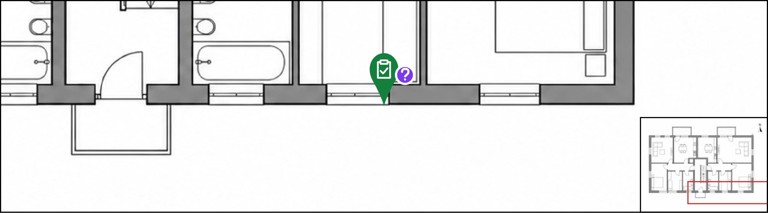
Component | Façade crack · Window opening

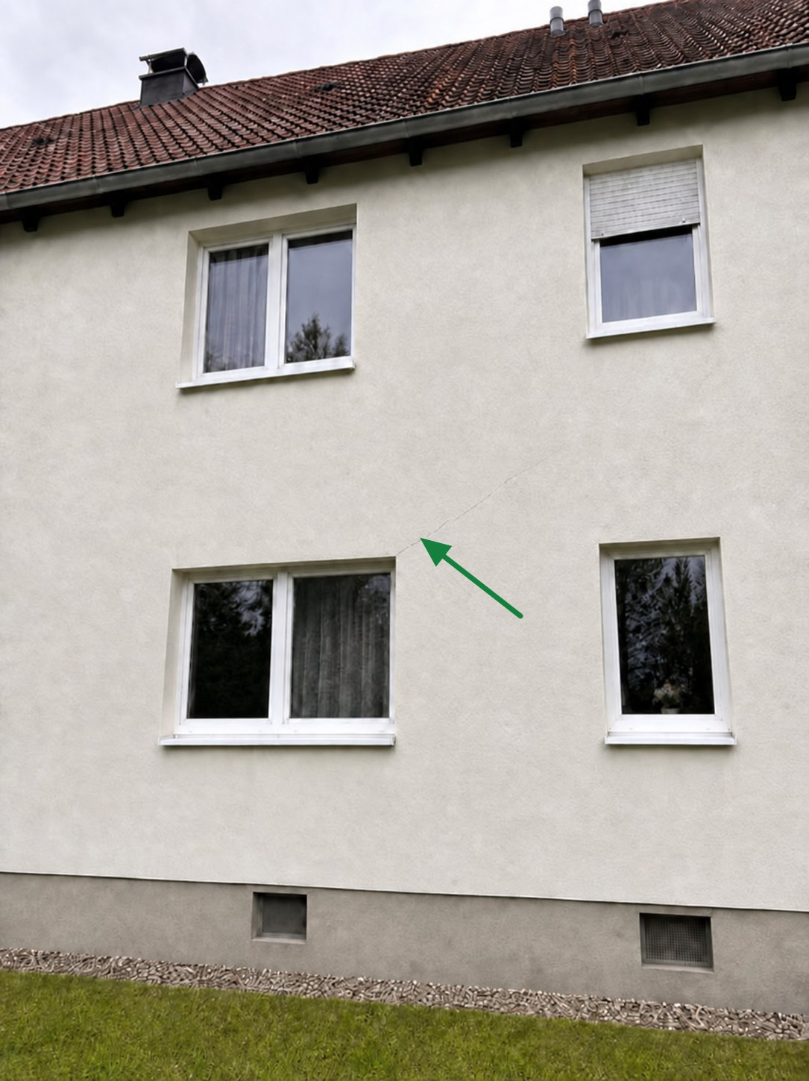  Figure 7 · South elevation - western ground-floor window  ● Crack inspection | Location and context - window corner  The marked area is above the upper-right corner of the western ground-floor window on the south elevation. The overview records the crack in relation to the window opening. The detail photograph provides the closer view used for the finding.

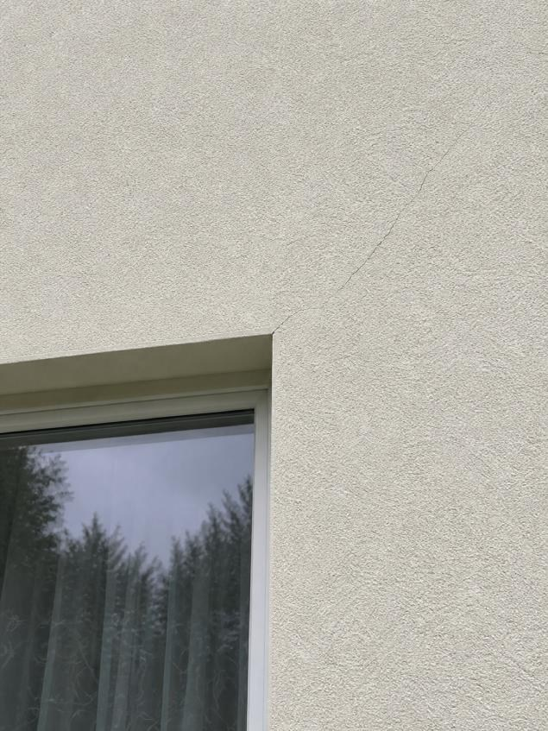  Figure 8 · Façade crack · Window opening | Finding - diagonal crack above the window  At the western ground-floor window on the south elevation, a fine crack starts at the upper-right corner of the opening and extends irregularly upwards to the right through the external render. Its visible length is approximately 1.20 m, estimated visually.  The opening appears predominantly hairline at the available viewing distance. No measured crack width is recorded. No adjoining render spalling is apparent in the photographs.  No opening-up, internal inspection or movement monitoring was undertaken. Opening geometry, render shrinkage or differential movement may contribute to this pattern; the cause and whether movement is continuing remain unconfirmed. Record measured widths, dated photographs with a scale and the condition of the corresponding internal surface before agreeing monitoring and repair.

Tasks and measures
Task 3 · Review the documented crack at the window opening
Responsible | Jonas Berger · Fassadenwerk · Beispiel
Status | Ready for review
Deadline | 20 Oct 2026 (Europe/Berlin)
Ready for review since | 19 Oct 2026 03:45 (Europe/Berlin)
Comments | The initial condition has been recorded. Ready for professional review.
Evidence | Figure 8

Safety observation
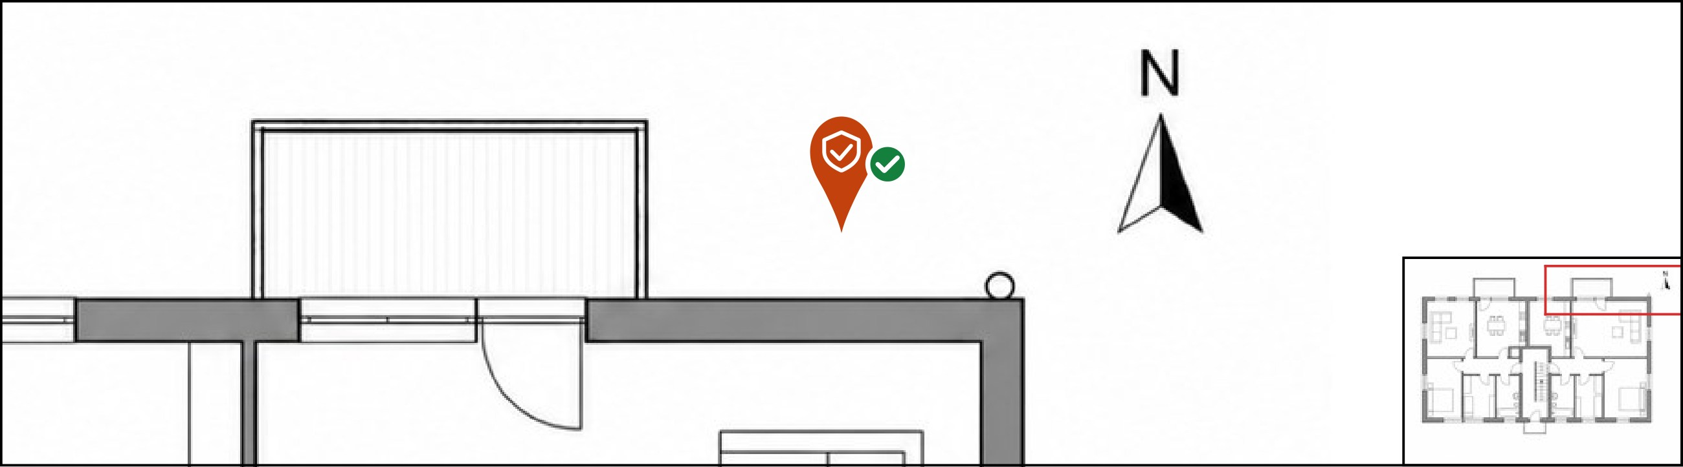
Component | Access below the balcony

Precautionary access restriction
The precautionary restriction concerns the north garden area immediately below the eastern first-floor balcony. Its location is separate from the south entrance. The barrier task is recorded as completed by Lena Weber in the follow-up record.
Completion of the barrier task does not close the concrete defect or authorise reopening. Maintain the restriction and arrange competent review of the balcony before access conditions are changed. No photograph of the barrier has been supplied with this record.

Tasks and measures
Task 4 · Secure the access area below the balcony
Responsible | Lena Weber · Lindenbau · Beispiel
Status | Closed
Deadline | 18 Oct 2026 (Europe/Berlin)
Completed on | 19 Oct 2026 03:45 (Europe/Berlin)
Comments | Barrier installed and completion recorded by the site manager.

Photo location
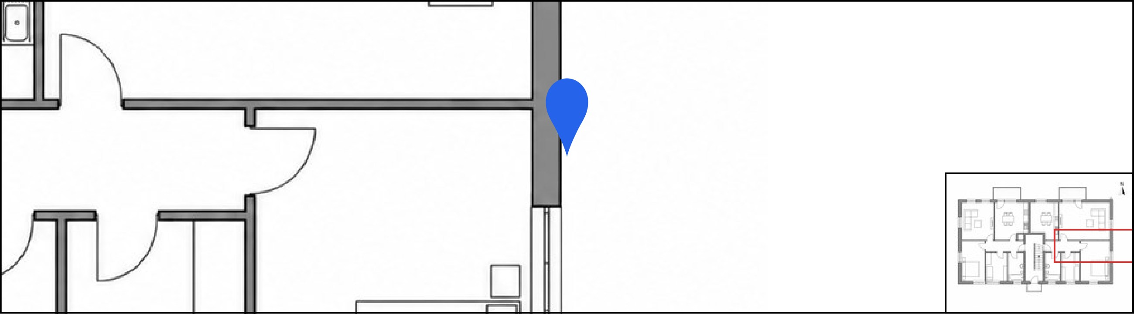
Component | Building overview

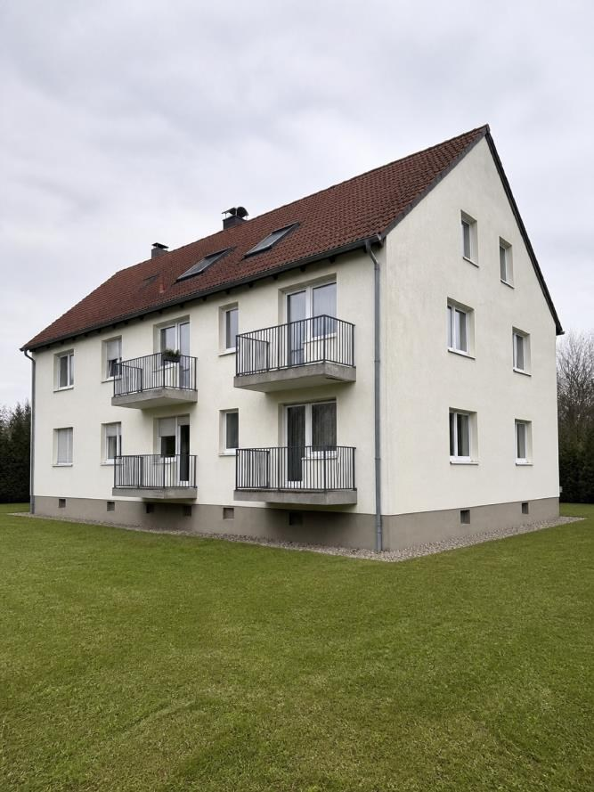  Figure 9 · Building overview | Building and orientation  The overview photograph records the rendered apartment building and its projecting balconies. Elevation names and inspection locations are identified on the schematic plan. The plan is an orientation aid and is not a measured survey.  This inspection addresses the specific externally visible findings documented here. Areas outside the recorded viewing positions and concealed construction were not assessed.

Technical assessment
The balcony has the highest follow-up priority because concrete cover is missing, reinforcement is exposed and further material may be loose. The visual record does not establish the remaining steel cross-section or structural capacity.
The plinth staining and deposits suggest a moisture-related process. A leaking downpipe, splash water or the ground/plinth junction are possible sources requiring investigation. The photographs do not demonstrate a particular cause or identify the deposits as salts.
The window-corner crack requires a measured baseline and observation of change. Its visible appearance alone does not establish whether it is confined to render, extends into the background construction, or remains active.

Recommended further action
1. Balcony: maintain the precautionary restriction below the defect. Arrange close inspection of the slab and reinforcement condition and agree further investigation before specifying repairs. Lena Weber is coordinating this task, due 23 October 2026.
2. Plinth: inspect the downpipe and drainage connection and take comparative moisture readings within and outside the visibly affected area. Mara König is responsible. This follow-up was due at the end of 18 October and remains open in the 19 October review.
3. Window corner: obtain a measured crack record, review the corresponding internal area and agree monitoring intervals. Jonas Berger has submitted the initial photographic record for review, due 20 October 2026.
4. Access: retain the completed barrier arrangement until the balcony investigation supports a change. Closure of this separate precautionary task does not confirm completion of concrete repairs.

Summary and follow-up
The inspection records three principal findings: concrete spalling with exposed reinforcement at the north balcony, staining and deposits at the west plinth, and a diagonal crack above a south-elevation window. Further investigation is required before the causes, full extent and suitable repairs can be established.
Follow-up status on 19 October 2026: balcony investigation in progress; plinth investigation open and overdue; crack record ready for review; precautionary barrier task closed. Responsibilities, deadlines and subsequent evidence remain linked to the original findings in the task overview.

